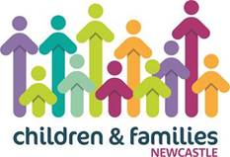
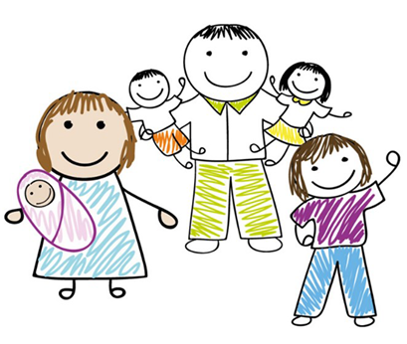
Healthy Family Relationship Support

Arguments in relationships are normal, but if you find yourself doing any of the following with your partner or co-parent, you may need help to sort things out.
Arguing often
• Not resolving arguments
• Walking away from arguments
• Feeling angry and shouting
• Arguing in front of children
For information about free relationship Support, scan the QR code to reach
Newcastle Support Directory.

