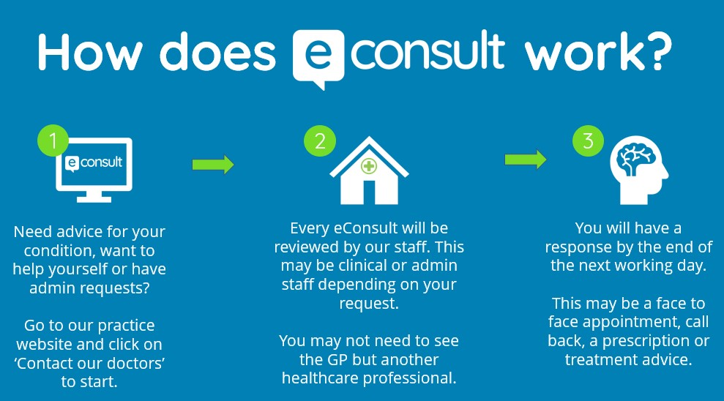
Key capabilities on eConsult include:
Online Consultations: Submit details about new or existing symptoms for a GP to review, allowing for triage and appropriate care (e.g., phone call, video, or in-person appointment).
Administrative Requests: Request fit notes (sick notes), test results, or ask about referrals without needing an appointment.
Self-Help & Signposting: Access trusted NHS advice for self-treating conditions or find local services, such as pharmacies.
Condition Monitoring: Submit information, such as blood pressure readings, for regular health check-ups.
Digital Convenience: Accessible from smartphones, tablets, or computers via a GP practice website or the NHS app.

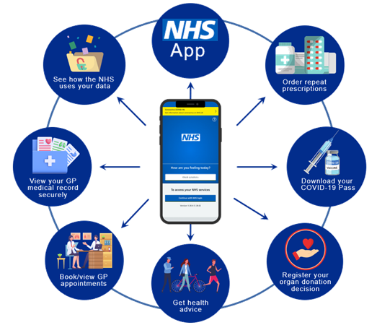
Key Functions of the NHS App:
GP Services: Book/cancel appointments, view health records (including new entries, test results, and correspondence), and message the surgery.
Prescriptions: View, request, and track repeat prescriptions and choose a pharmacy for electronic pickup.
Hospital Referrals: View, track, and manage hospital appointments and referrals.
Health Information: Check symptoms, find NHS services, and manage organ donation decisions.
Notifications: Receive messages from the GP surgery and access health information.
Linked Profiles: Manage the health of others, such as children or dependents.

Key Features of the myGP App:
Manage Appointments: Book, cancel, or view appointments, including routine GP appointments, even when the surgery is closed.
Order Prescriptions: Request repeat prescriptions directly through the app, which can be linked to Patient Online Services.
Medical Records & Information: View parts of your GP health record, such as vaccinations and test results.
Medication Reminders: Set notifications to help remember to take medication.
Health Tracking: Monitor and record health data like blood pressure, weight, and other vitals.
Circle of Care: Add family members or dependents to manage their appointments and care.
Messaging: Receive appointment reminders and communicate with your GP practice.
Additional Services: Access features like a skin scanner and health advice.

